An example of how the New Competence for SMEs slide set can be used

You can find the New Competence for SMEs material at www.uuttaosaamista.fi

An example of how the material can be used to start a discussion with companies:
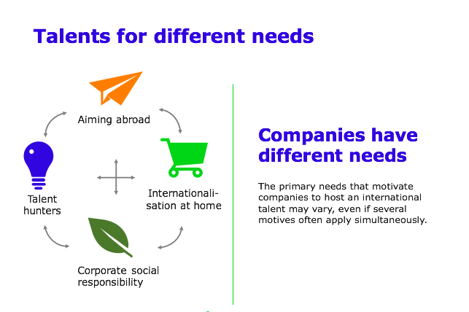

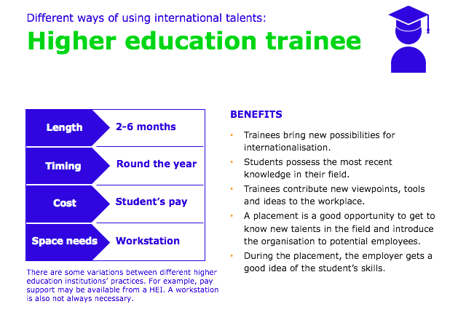

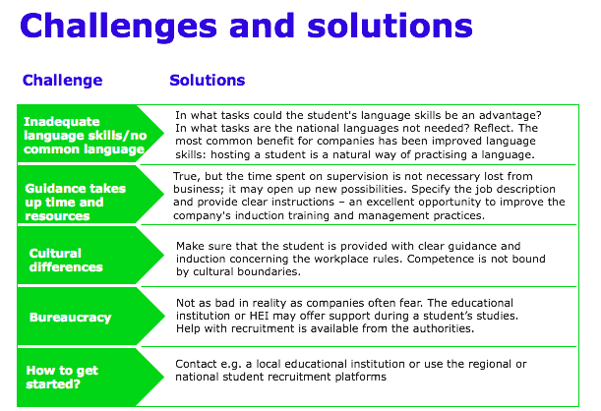

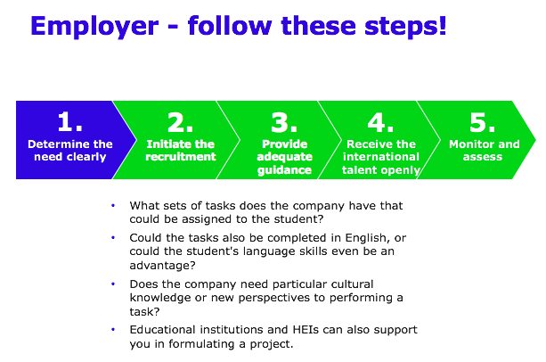

Educational institutions can freely use the slides and adapt them to their own purposes.

- Talents for the different needs of different companies: A model with four categories based on study results is used as background material.
  - Company representatives can place themselves in the model following the classification and consider why and for what types of needs the company may use international talents. If the company has already hosted international talents, the tasks they performed are discussed, and any other possibilities and needs for utilising talents can be considered.
  - The task of the educational institution/stakeholders is to support the companies in classifying themselves.

- Different ways of benefitting from international talents: The slides contain summaries of and potential benefits offered by different possibilities: higher education trainees, VET students on work placement, commissioning a thesis, implementing a student project and recruiting a degree student. The educational institutions can themselves complement the slides based on what they offer.
  - Companies are asked to describe their needs, and educational institution representatives can explain how this need could be met. The background material is left with the company for future reference.
  - In connection with companies’ preferences concerning the cooperation, the questions that should be answered include the field in which the companies need talents, the purposes for which talents are needed, and the preconditions for hosting talents.

- The following steps contain slides on ”challenges and solutions” as well as slides with instructions for companies (”Employer – follow these steps!”).
  - Companies are asked to describe their fears or challenges related to hosting a foreign student, and the solutions are discussed with them. Companies that have had international talents can consider solutions to challenges that they encountered together with the educational institution representatives.

Finally, a summary is produced, ensuring that the actors have a clear idea of how to start off and whom to contact as the next step. At the same time, the companies are also given an opportunity to describe their preferences concerning future cooperation.

When the educational institution/HEI produces its own version of the material, a summary of the cooperation possibilities can be included on three slides, for example as follows:
- Possibilities for cooperation aiming to promote companies’ internationalisation or to utilise international talents (e.g. placements, projects etc.)
- Sectors and amounts of students from different countries
- Contact details of the person responsible for business cooperation at the educational institution/HEI

